1. Open Session Billing Budget from Menu Browser.

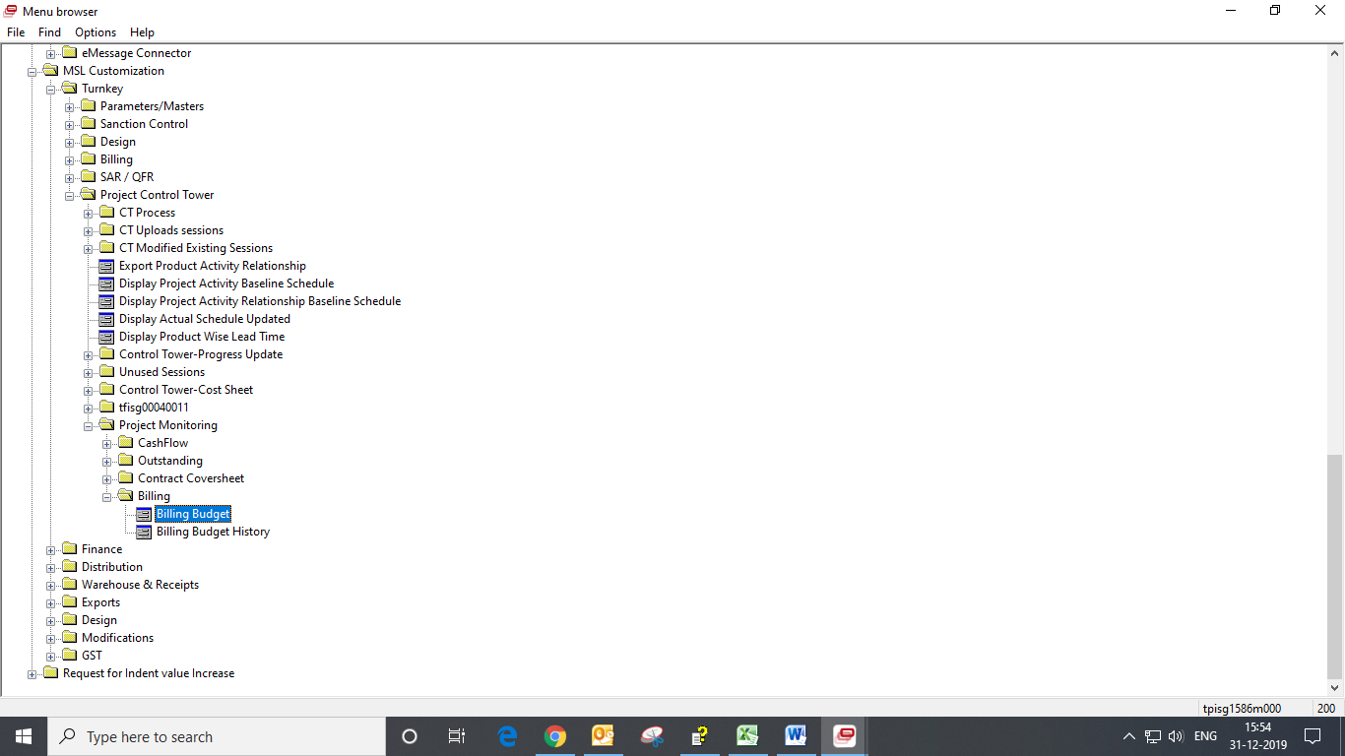

1. Double Click on Record to view Budget Details. And History can be viewed from Specific Menu.

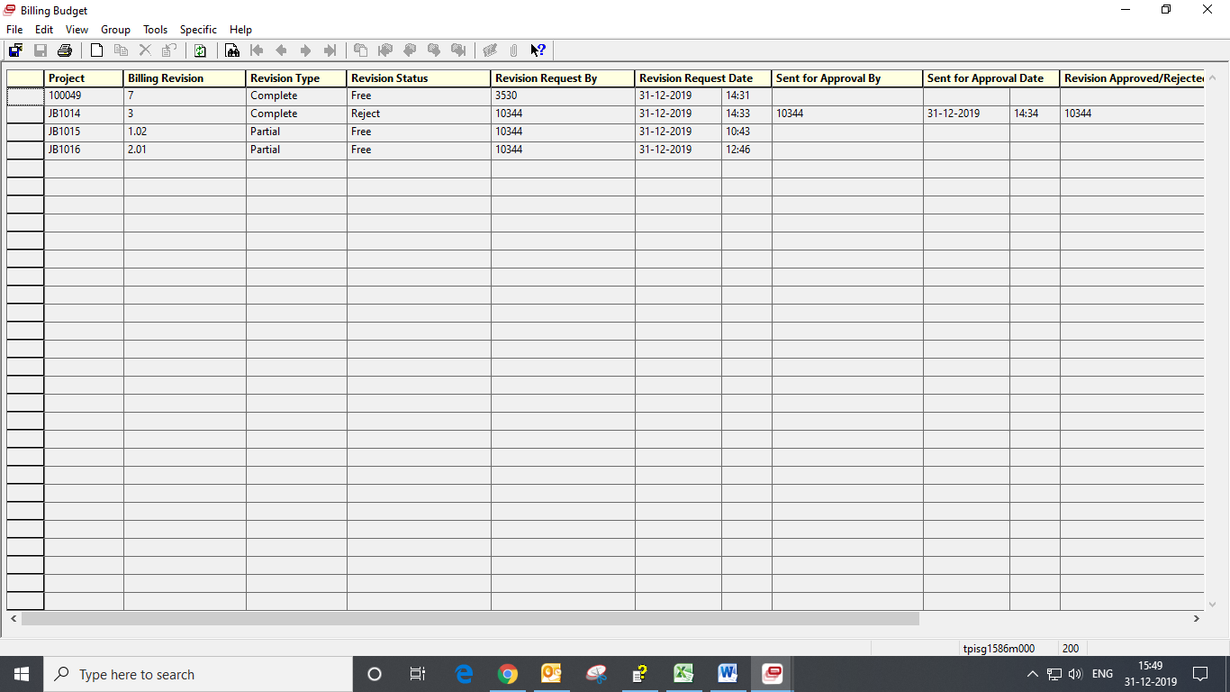

1. Through the Contract Creator and Approval Matrix, Project Budget can be revised completely or partially. The Creator first sends the Billing Budget for approval and the Approver can either approve or reject the budget after checking the data. Later, the approver can revise the budget completely or partially. If the budget is completely revised the new revision gets created with a +1 and if the budget is partially revised the new revision gets created with a +0.01. Also, the older revision gets stored in the Billing Budget History.
2. In the Header Session, the user must select the Reason for Complete Revise before proceeding further and enter the Remarks.
3. In the Budget Billing Lines Session, the user enters the Year, Month, Budgeted Billing, Outlook and Reason of Variance. The Actual Billing gets populated automatically through separate logic.

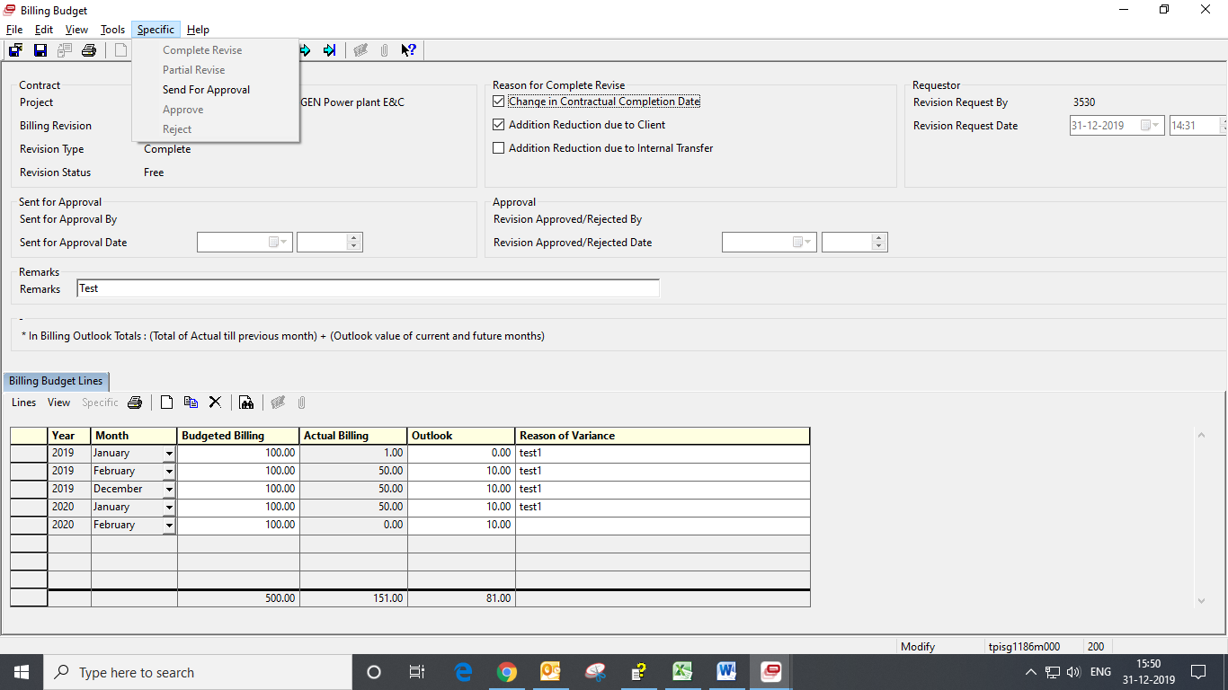

1. Billing Budget History can also be opened through Menu Browser.

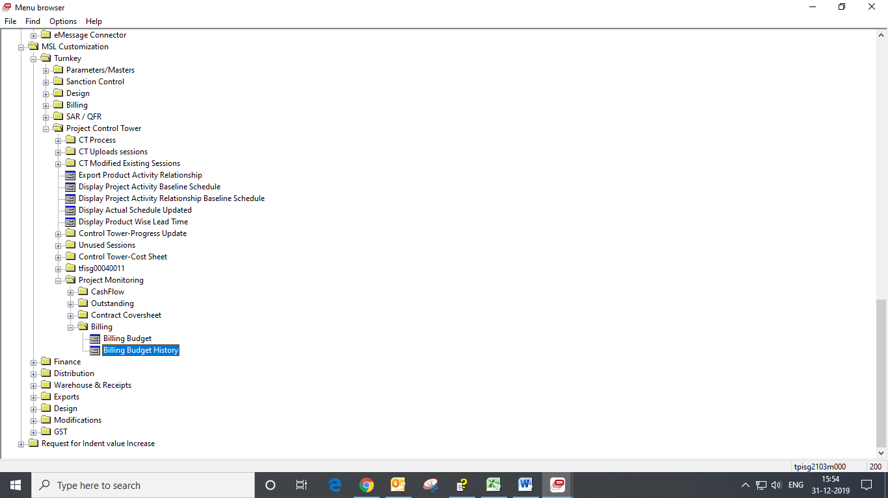

1. History can be viewed in a separate Details Display Session and navigated through previous and next buttons.

